**Case study:**

**Implementing atm machine application:**

**Description:**

This case study explains the functionality of the automated teller machine (atm) and the basic operations that atm machine do like withdraw money, deposit money, validation user details, terminate the transaction while details are wrong and check balance enquiry of user account. Here we are going to discuss the step by step operations that atm machine will do.

**Operation:**

Atm is a machine with screen, keyboard, speaker, receipt printer, cash and card dispensers for the user. When a person reaches atm. Screen displays welcome message and request to “insert the debit (or) credit card**”.** Next step will depend upon the type of card that is inserted.

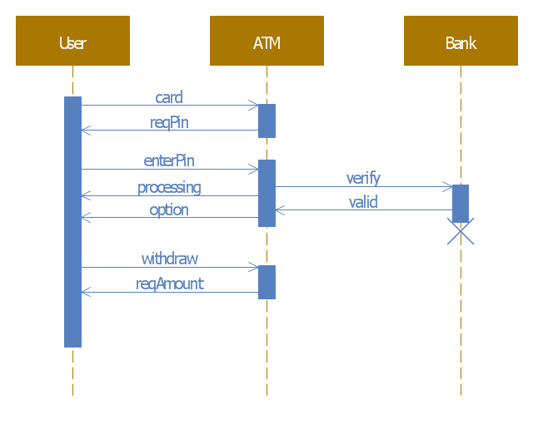

**1. Debit card**

If the inserted card type is of debit, the server connects with particular bank account database and displays in the screen to enter for the pin. If entered user pin matches with requested account database pin, then the server will proceed in to user bank account and displays options to perform in main menu.

1.1 withdraw amount

1.2 deposit amount

1.3 balance enquiry

1.4 mini statement

1.5 void transaction

**1.1 Withdraw amount:**

If user choose to withdraw amount, then screen will request to enter the amount that user want to withdraw. As a next step server will check with the user bank account to confirm that the requested withdraw amount is less than available balance in user account.

**Requested amount <= balance amount:**

If users requested amount is less than or equal to available balance. Then, the transaction will be processed by updating the balance amount with

**Balance amount = balance amount – requested amount.**

And prints the withdrawn amount and available balance after the withdraw transaction.

**1.1.1Make another withdraw:**

If user choose to make another withdraw transaction, then screen will request to enter the amount that user want to withdraw. As a next step server will check again with the user bank account to confirm that the requested withdraw amount is less than available balance in user account.

**Requested amount <= balance amount:**

If users requested amount is less than or equal to available balance. Then, the transaction will be processed by updating the balance amount with

**Balance amount = balance amount – requested amount.**

And prints the withdrawn amount and available balance after the withdraw transaction.

**Requested amount > balance amount:**

If users requested amount is greater than available balance. Then, screen will pop-up with an error message with **“**incorrect request” by terminating the transaction and redirecting to the main menu showing option again to perform.

1.1.2 **back to main menu:**

If user wants to go back to main menu directly by terminating the next withdraw operation, they can choose “back to main menu” option which takes user back to main menu screen to choose options.

1.1.3 **exit:**

User can void entire transaction and disconnect with server directly by choosing “exit” option. So that account will be logged out by dispensing out the debit card and displaying “thank you for the transaction” message on the screen.

**1.2 deposit amount:**

When the user choose to deposit amount. Screen will display a message **“**insert cash that is not more than 40 bills**”** and alert the cash dispenser to count cash and reject bills if they are more than 40bills or found fake or found folded. Then display the total counted bills and amount to confirm from the user.

**Correct amount:**

If user confirms the correct amount. Then update the balance amount with deposited amount and prints the latest updated balance amount after deposit transaction.

**Balance amount = balance amount + deposit amount;**

1.2.1 **make another deposit:**

If user wants to make another deposit, then can choose “make another deposit” and again. Screen will display a message **“**insert cash that is not more than 40 bills**”** and alert the cash dispenser to count cash and reject bills if they are more than 40bills or found fake or found folded. Then display the total counted bills and amount to confirm from the user.

**Correct amount**

If user confirms the correct amount. Then update the balance amount with deposited amount and prints the latest updated balance amount after deposit transaction.

**Balance amount = balance amount + deposit amount;**

**Wrong amount**

If user confirm the total amount is wrong. Alert the cash dispenser to recheck the bills and display the total amount to confirm from the user again.

1.2.2 **back to main menu:**

If user wants to go back to main menu directly by terminating the deposit operation, they can choose “back to main menu” option which takes user back to main menu screen to choose options.

1.2.3 **exit:**

User can void entire transaction and disconnect with server directly by choosing “exit” option. So that account will be logged out by dispensing out the debit card and displaying “thank you for the transaction” message on the screen.

**1.3 balance enquiry:**

When user choose for “balance enquiry” in main menu, server will check database and prints the balance amount from the user bank account.

1.3.1 **back to main menu:**

If user wants to go back to main menu directly by terminating the balance enquiry operation, they can choose “back to main menu” option which takes user back to main menu screen to choose options.

1.3.2 **exit:**

User can void entire transaction and disconnect with server directly by choosing “exit” option. So that account will be logged out by dispensing out the debit card and displaying “thank you for the transaction” message on the screen.

**1.4 mini statement:**

User can print there last 5 transactions by sorting data function on choosing “mini statement” option from main menu in screen.

**1.5 void transaction:**

Once user is in main menu, they can terminate the entire transactions by disconnecting the server and dispensing out the debit card with message “transaction voided” on the display screen.

|  |  |
| --- | --- |
|  | **Class: debit card** |
|  |  |
| **+ int: deposit amount;** |
|  |
|  | **+ int: withdraw amount;** |
|  | **+ int: balance enquiry;** |
|  | **- int: pin;** |
|  | **+ int: mini statement;** |
|  | **+ int: void transaction;** |
|  | **Private: balance amount()** |
|  | **Public: validate pin()** |
|  |  |

Note : + is public and – is private

**2. Credit Card**

Credit Card functionality is very much different on comparing with Debit Card Including additional methods like Calculating Interest Rate for every month and Every Transaction. If the Inserted Card type is of Credit, then Server connects with particular account Database and checks with the card Expire Date. If True, then Displays the following options in main menu.

**ExpirationDate == valid**

If Card Expiration Date matches with the Date in Account Database. Then Displays the following options to operate the Account.

1. Cash Advance
2. Pay Bill
3. Balance Enquiry
4. Mini statement
5. Void Transaction

**ExpirationDate != Valid**

If Card Expiration Date don’t match with Date in Account Database. Server will void the action and pops out the card by displaying “Invalid Card”.

1.1 **Cash Advance:**

If a user wants to take Cash Advance from his account by choosing “Cash Advance” option from Main Menu. Server will check with the particular account about how much cash advance is allowed for a particular type of account, what amount of cash advance will be charged interest and if so, what is the amount of interest that will be charged.

Due Amount = Cash Advance + Due Amount;

Once User done with there Transaction. Displayed Server options are.

1.1.1 **Make Another Cash Advance:**

User can make another Cash Advance Operation by choosing “Make Another Cash Advance” key and once done, display prints out with the updated Cash Advance Amount by updating Due Amount

Due Amount = Cash Advance + Due Amount;

1.1.2 **Main menu:**

User can return back to main menu by choosing “Main Menu”

1.1.3 **Exit:**

User can Terminate the Server and take the card by choosing “Exit”.

1.2 **Pay Bill:**

Once a user chooses “Pay Bill” to pay there Due bill from Main Menu options and after entering the amount, Due bill Amount will be updated and prints paid amount and updated Due Amount.

Due Amount = Pay Bill – Due Amount;

1.2.1 **Make Another Pay Bill:**

User can make another Pay Bill Operation by choosing “Make Another Pay Bill” option and once done, Display prints out with the updated Due Bill Amount and Payed Amount by updating Due Amount in Data base

Due Amount = Pay Bill - Due Amount;

1.2.2 **Main Menu:**

User can return back to main menu by choosing “Main Menu”

1.2.3 **Exit:**

User can Terminate the Server and take the card by choosing “Exit”.

1.3 **Balance Enquiry:**

When user choose for “Balance Enquiry” in Main Menu, Server will check Database and prints the Due Amount from the user Credit account.

1.3.1 **Back to Main Menu:**

If user wants to go back to Main menu directly by terminating the Balance Enquiry operation, they can choose “Back to Main Menu” option which takes user back to main menu screen to choose options.

1.3.2 **Exit:**

User can void Entire Transaction and disconnect with server directly by choosing “Exit” option. So that Account will be logged out by dispensing out the Debit card and Displaying “Thank you for the Transaction” Message on the Screen.

**1.4 Mini Statement:**

User can print there last 5 Transactions by sorting data function on choosing “Mini Statement” option from Main Menu in Screen.

**1.5 Void Transaction:**

Once User is in Main Menu, they can Terminate the Entire Transactions by Disconnecting the Server and Dispensing out the Credit card with Message “Transaction Voided” on the Display Screen.

**Class : Credit Card**

* **int: Cash Advance;**
* **int: Pay Bill;**
* **int: Balance Enquiry;**
* **int: Mini Statement;**
* **int: Void Transaction; Private: Due Amount() Private: Validate Date()**